EXERCISE 2
- SELECT emp_id FROM employee_data WHERE age > 30;
- SELECT f_name, l_name FROM employee_data WHERE title = ‘Web Designer’;
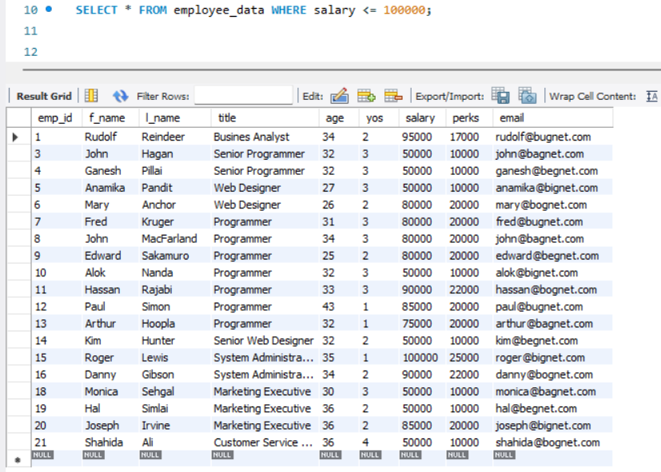

- SELECT salary, perks FROM employee_data WHERE perks > 16000;
- SELECT l_name, f_name FROM employee_data WHERE title = ‘Marketing Executive’;

